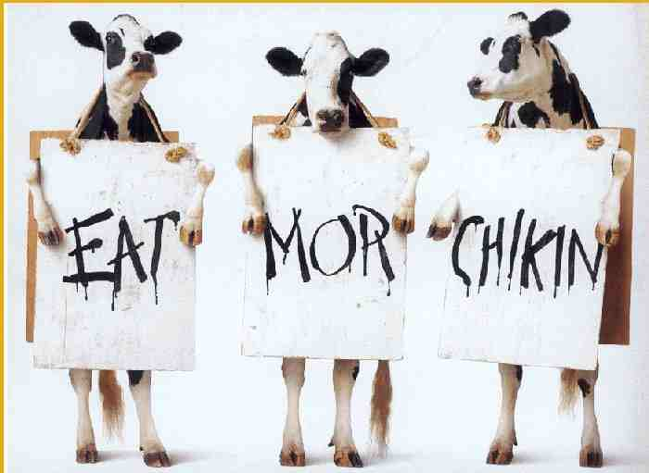
Meat Raffle
Saturday,
March 28, 2020
7 p.m.
Doors open at 6 p.m.

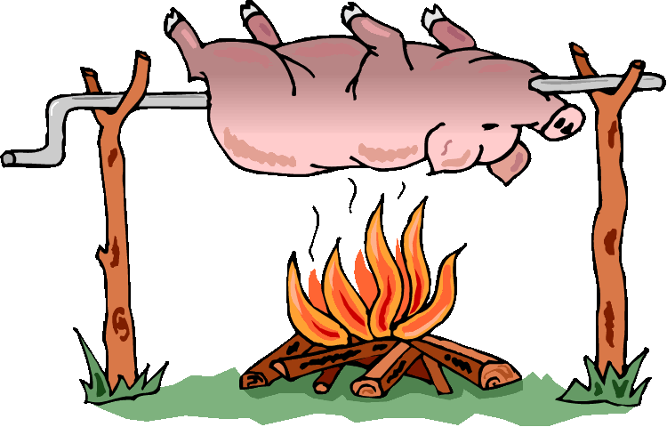
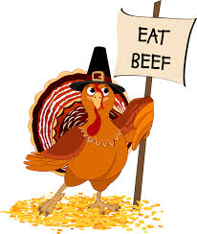
at the
VFW Post 4156 Hall
321 Union Lake Rd., White Lake

Admission $15.00 per Person
Eat Chicken
Purchase tickets at the door

Grab a table for you or your group and bring your own snacks. Invite your family, friends, and co-workers. The more the merrier. Don’t forget to bring your cooler for all your winnings.
Questions ?
Linda Gloger
248-330-8442 RAFFLE
BASKETS
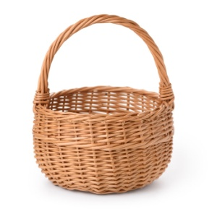

Sponsored by VFW Post 4156 VFW Auxiliary, Proceeds will be used towards VFW programs

